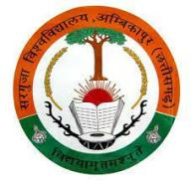
SANT GAHIRA GURU VISHWAVIDYALAYA, SARGUJA AMBIKAPUR (C.G.)
University Teaching Department

Name of Department- Department of Legal Studies
Regular Faculties
S, No. | Photo | Name of Faculty | Qualification | Designation | Specialization | Mob. No. | E-Mail ID
 | 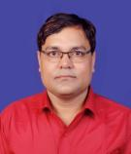 | Dr. Saman Narayan Upadhyay | Ph. D.  UGC NET  RPSC SET  LL.M. | Assistant Professor (Selection Grade) | Constitutional Law, Environmental Law, Sustainable Development, Human Rights Law | 7049804100 | snuacad@gmail.com

Guest Faculties
S, No. | Photo | Name of Faculty | Qualification | Designation | Specialization | Mob. No. | E-Mail ID
 | 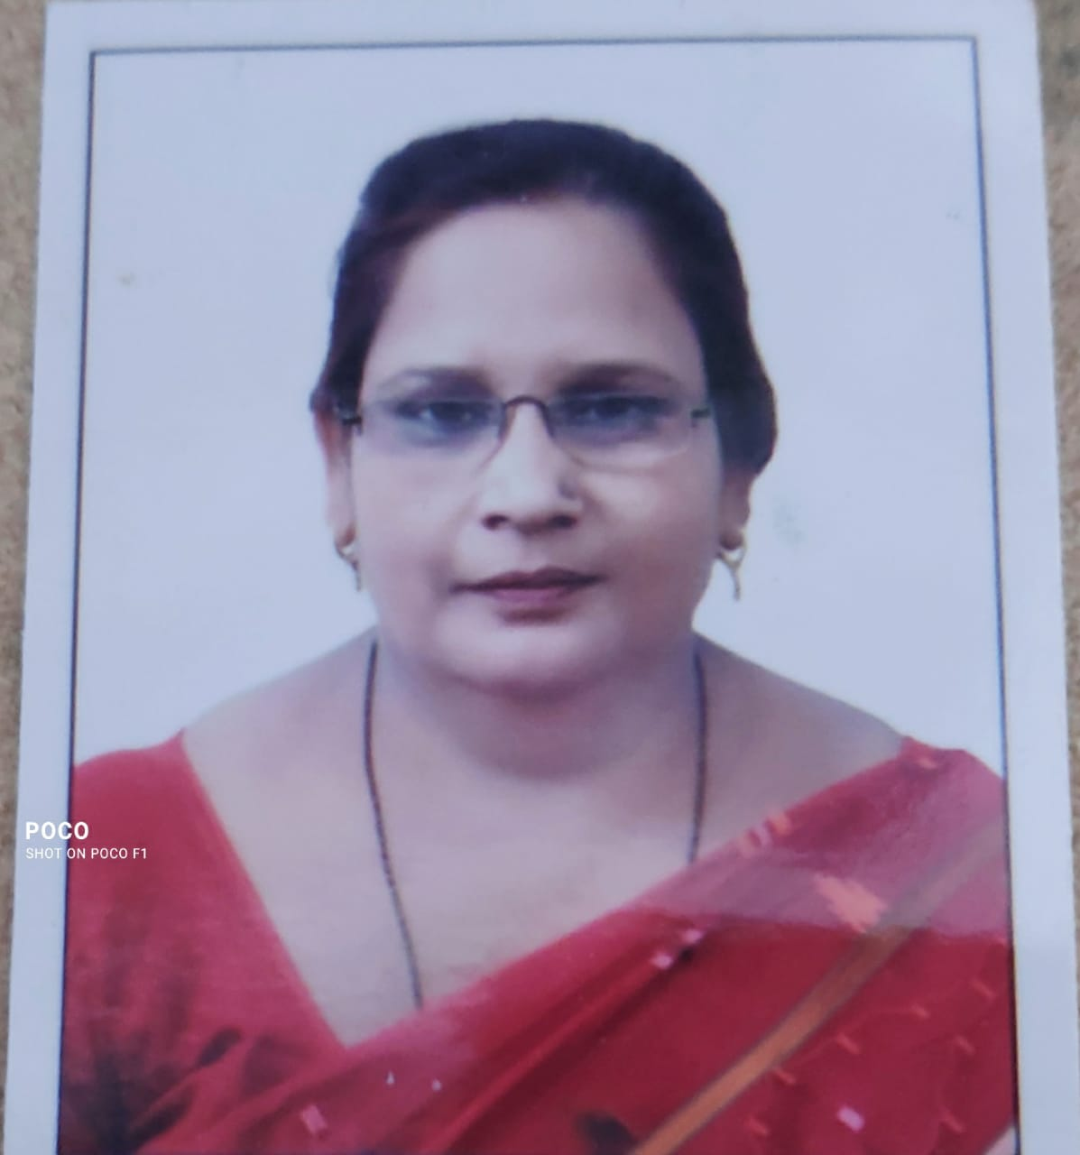 | Dr. Neema Qamar | PhD, LL.M, M.A. Political Science | Guest Faculty | Personal Law | 8461045228, 9425365093 | neemaqamar785@gmail.com
 | 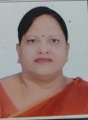 | Usha Agrawal | CG SET Qualified, LL.M, Pursuing Ph.D | Guest Faculty | Human Rights | 9826112032 | usha_tax_advocate@yahoo.co.in
 |  | Nasimuddin Khan | UGC NET Qualified, LL.M, Pursuing Ph.D | Guest Faculty | Corporate & Intellectual Property Law | 8878380207,  7828046618 | nasim.khan0826@gmail.com

