
SANT GAHIRA GURU VISHWAVIDYALAYA, SARGUJA AMBIKAPUR (C.G.)
University Teaching Department

Name of Department – Farm Forestry
Regular Faculties
S, No. | Photo | Name of Faculty | Qualification | Designation | Specialization | Mob. No. | E-Mail ID
1 |  | DR. SUSHMA KERKETTA | Ph.D. (Forestry)  M.Sc. (Agro-forestry)  B.Sc. (Biology)  NET (Forestry) | HOD (I/C)  Assistant Professor | - Agroforestry  - Silviculture  - Remote sensing and GIS  - Watershed Management | 7587401865 | sushmabhel@gmail.com
2 |  | DR. DHIRAJ KUMAR YADAV | Ph.D. (Forestry)  M.Sc. (Forestry)  B.Sc. (Forestry)  MBA (HRM)  NET (Forestry)  NET (Forestry and Environmental Sciences) | Assistant Professor | - Forest Ecology  - Medicinal and Aromatic  - Biodiversity Assessment  - Human Elephant Conflicts  - Remote sensing and GIS | 9926615061 | dheerajforestry@gmail.com
3 |  | DR. MANOJ KUMAR JHARIYA | Ph.D. (Forestry)  Gold Medalist  M.Sc. (Forestry)  B.Sc. (Agriculture)  NET (Environmental Sciences)  NET (Agroforestry) | Assistant Professor | - Forest Ecology  - Agroforestry  - Biodiversity Assessment  - Mining Ecology | 9407004814; 9713043786 | manu9589@gmail.com
Guest Faculties
S, No. | Photo | Name of Faculty | Qualification | Designation | Specialization | Mob. No. | E-Mail ID
1 |  | DR. JAIMANGAL TIRKEY | Ph.D. (Forestry)  M.Sc. (Forestry)  B.Sc. (Agriculture) | Assistant Professor | - Silviculture  - Forest Ecology  - Forest Genetics  - Biodiversity Assessment | 7987906573 | jtirkey482@gmail.com
2 | 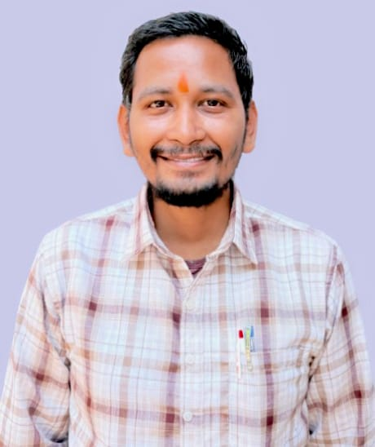 | DR. MANISH KUMAR MANKUR | Ph.D. (Forestry)  M.Sc. (Forestry)  B.Sc. (Forestry) | Assistant Professor | - Silviculture  - Forest Pathology  - Agroforestry  - Forest Nursery Management  - Forest Legislation
3 | 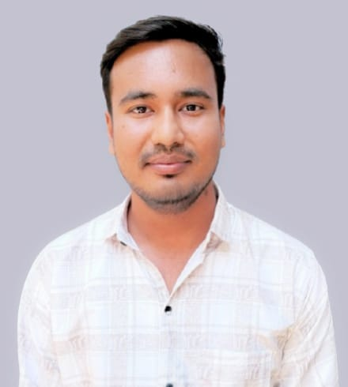 | MR. PANKAJ | M.Sc. (Forestry)  B.Sc. (Agriculture)  NET (Environmental Sciences) | Assistant Professor | - Silviculture  - Agroforestry  - Forest Mensuration  - Remote Sensing and GIS  - Watershed Management | 9111641322 | Pankajverma1648@gmail.com

