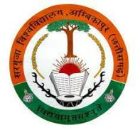
SANT GAHIRA GURU VISHWAVIDYALAYA, SARGUJA AMBIKAPUR (C.G.)
University Teaching Department

Name of Department- Department of Computer Science
S.No. | Photo | Name of Faculty | Qualification | Designation | Specialization | Mob. No. | E-Mail ID
 |  | Hari Shankar Prasad Tonde | UGC NET  MCA | Assistant Professor | JAVA, WEB Development, Machine Learning | 919300764765 | hari.1978.rakhi@  gmail.com
Regular Faculties

Guest Faculties
S.No. | Photo | Name of Faculty | Qualification | Designation | Specialization | Mob. No. | E-Mail ID
 | 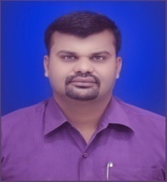 | Dr. Abhay Kumar Mishra | Ph.D. (CS), M.Phil. (CS),  M.Sc. (CS)  BCA | Guest Faculty | Networking,  ICT, Web Development | 919770086708 | Mishraji.abhay@gmail.com
 | 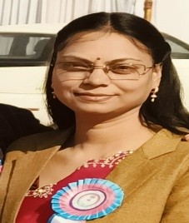 | Dr.Manisha Dewangan | Ph.D. (CS),  M.Phil. (CS),  M.sc (IT) | Guest Faculty | Operating System.RDBMS, Web Development, Machine Learning | 919753649924 | ranidevm@gmail.com

