DEPARTMENT OF PHARMACY
Faculty Details

S.No | Photo | Name | Designation | Qualification | Specialization | Mobile no. | E-mail id
1 |  | MOHAMMED JUNAID KHAN | HOD (I/C)  Assistant Professor | Ph.D., M. Pharm | Pharmacology | 9826141303 | junaid1010@gmail.com
2 | 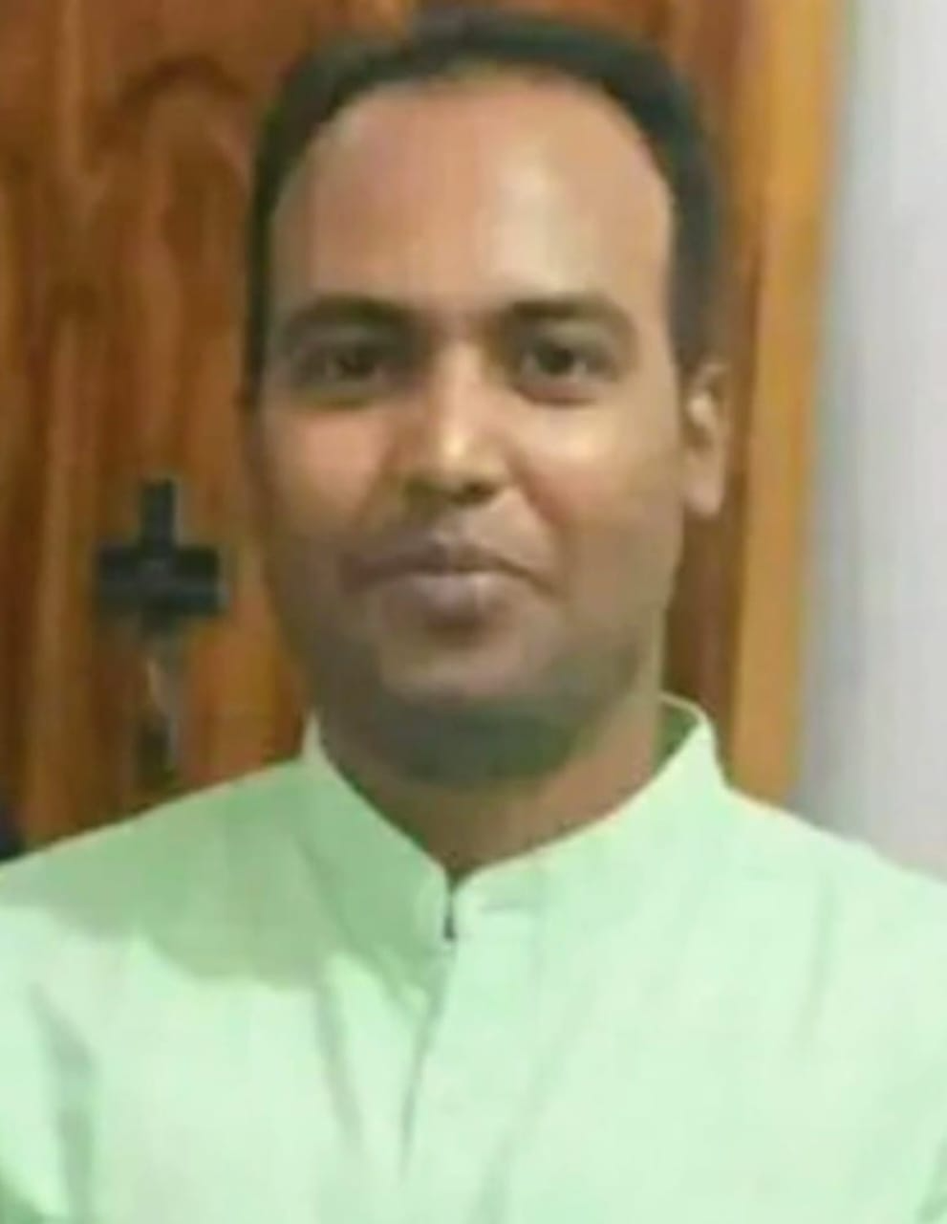 | ANAND KUMAR | Assistant Professor | M. Pharm | Pharmacognosy | 7581803698 | anandsutdop@gmail.com
3 | 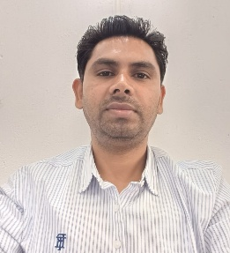 | KHEMKARAN AHIRWAR | Assistant Professor | M. Pharm | Pharmaceutical Chemistry | 8319142986 | khempharma@yahoo.co.in
4 | 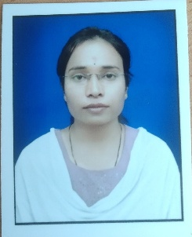 | ARTI BHAGAT | Guest Faculty | M. Pharm | Pharmaceutics | 7389684378 | artibhagat1412@gmail.com
5 | 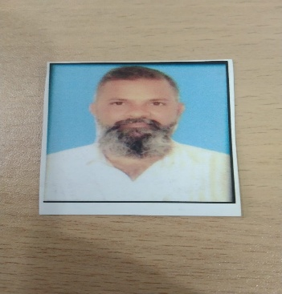 | ANEES AHMED | Guest Faculty | M. Pharm | Pharmacology | 9926376242 | aneesahmed.qc@gmail.com
6 | 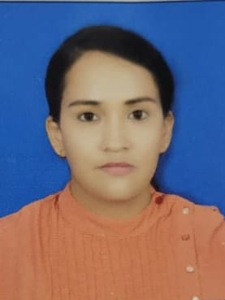 | NEHA DUBEY | Guest Faculty | M. Pharm | Pharmacology | 7089793803 | nehadubey2610@gmail.com

